W A N T E D
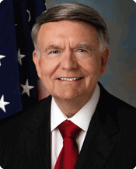

Robert M. Duncan
Chairman, Board of Governors
U.S. Postal Service

Crime: Obstructing the distribution of mail, sabotaging Democracy.

“Whoever knowingly and willfully obstructs or retards the passage of the mail, or any carrier or conveyance carrying the mail, shall be fined under this title or imprisoned not more than six months, or both.” Federal Criminal Law (18 USC 1701)

Reward: On-time delivery of prescription medications

On-time delivery of Social Security checks

A free and fair election!

To save the USPS, contact your members of Congress & state attorney general
More info: https://bit.ly/311kbEo
W A N T E D
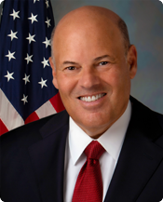

Louis DeJoy
Postmaster General & CEO
U.S. Postal Service

Crime: Obstructing the distribution of mail, sabotaging Democracy.

“Whoever knowingly and willfully obstructs or retards the passage of the mail, or any carrier or conveyance carrying the mail, shall be fined under this title or imprisoned not more than six months, or both.” Federal Criminal Law (18 USC 1701)

Reward: On-time delivery of prescription medications

On-time delivery of Social Security checks

A free and fair election!

To save the USPS, contact your members of Congress & state attorney general
More info: https://bit.ly/311kbEo

A free and fair election!
W A N T E D

Roman Martinez, IV
Member, Board of Governors
U.S. Postal Service

Crime: Obstructing the distribution of mail, sabotaging Democracy.

“Whoever knowingly and willfully obstructs or retards the passage of the mail, or any carrier or conveyance carrying the mail, shall be fined under this title or imprisoned not more than six months, or both.” Federal Criminal Law (18 USC 1701)

Reward: On-time delivery of prescription medications

On-time delivery of Social Security checks

A free and fair election!

To save the USPS, contact your members of Congress & state attorney general
More info: https://bit.ly/311kbEo

